**Assignment #3**

**CSP 554 – Big Data Technologies**

**Adarsh Mathad Vijayakumar – A20424847**

Question 6) Word count program.

Submit a copy of this modified program and a screen shot of the results of the program’s execution as the output of your assignment.

Screenshot of the output of the modified program WordCount2.py

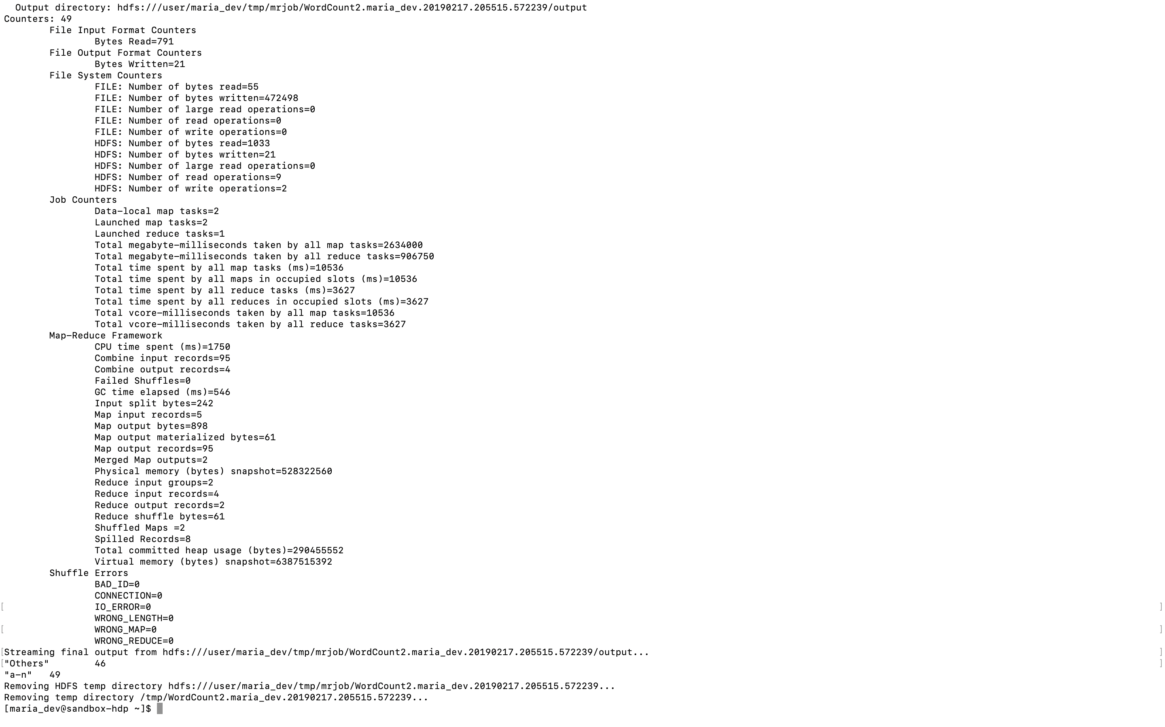

Question 10) Salaries program.

Submit a copy of this modified program and a screen shot of the results of the program’s execution as the output of your assignment.

Screenshot of the output of the modified program Salaries2.py

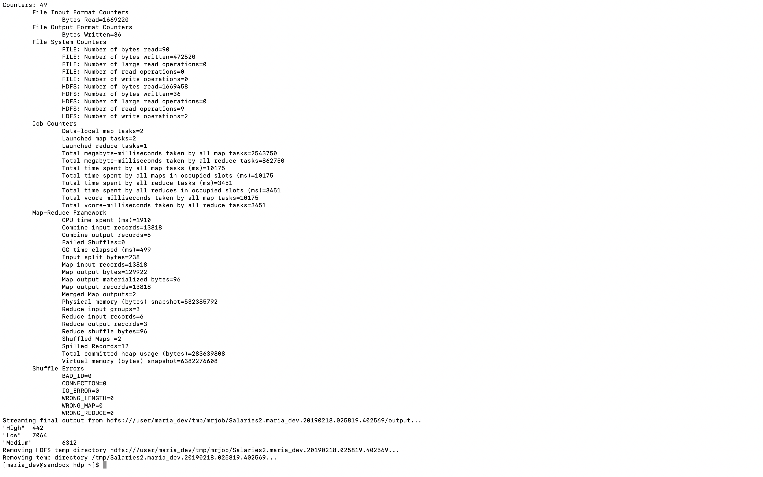

Question 12) Write a program to perform the task of outputting a count of the number of movies each user (identified via their user id) reviewed.

Submit a copy of this program and a screen shot of the results of the program’s execution (only 10 lines or so of the result) as the output of your assignment.

Screenshot of few lines from the output of the program MoviesCount.py

